Location Transfers

Use this option to transfer items between locations.
Location is the term in Sage for store, warehouse, etc.

Steps to do transfer of inventory items between stores
- Open Transfers. Navigation path: Inventory Control -> I/C Transactions -> Transfers
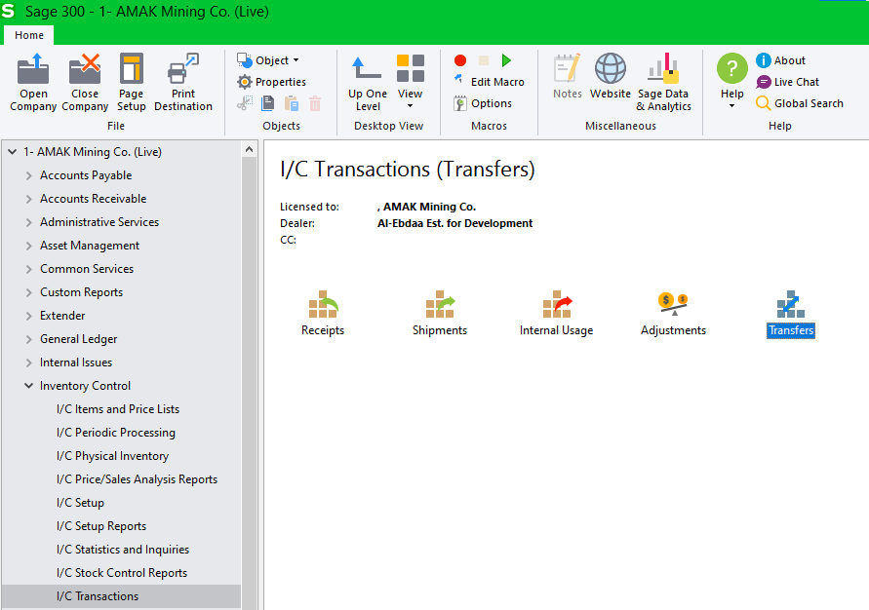

- The Tranfers screen:
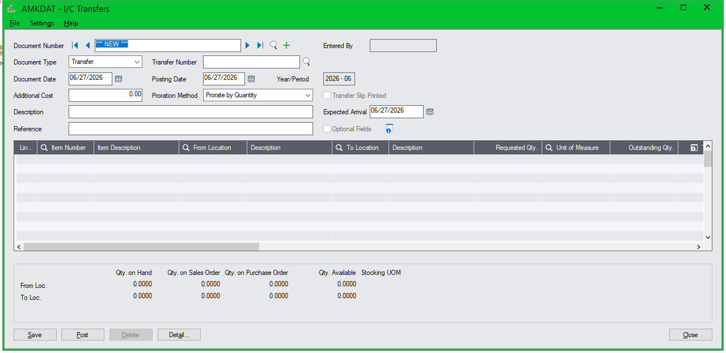

- Enter Date, Description and Reference information.
Document Date defaults to session date.
Posting Date defaults to Document Date.
Description is a general description of the transfer.
Reference is to document the source/reason for the transfer.
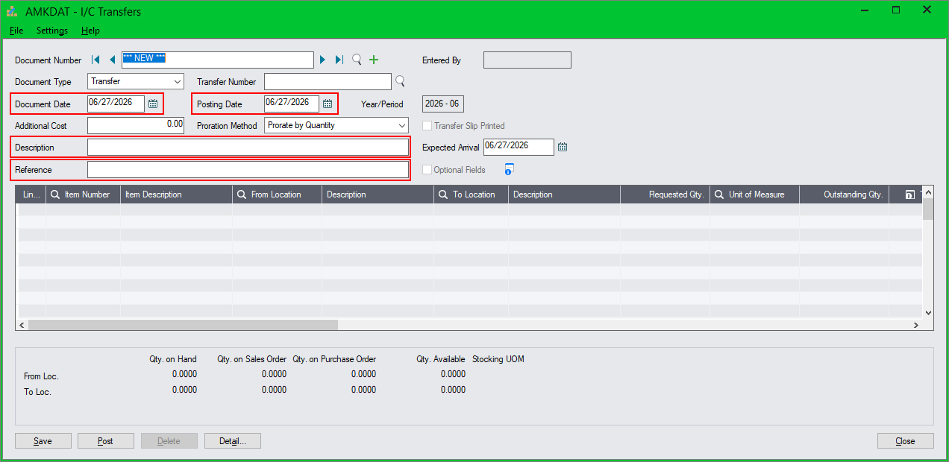
- Click in the item area
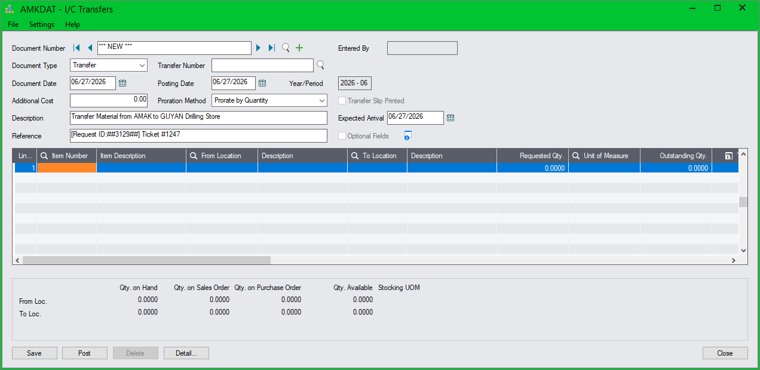

- Enter Item Number, From Location and To Location.
The Qty information for both locations will be shown at the bottom of the screen.
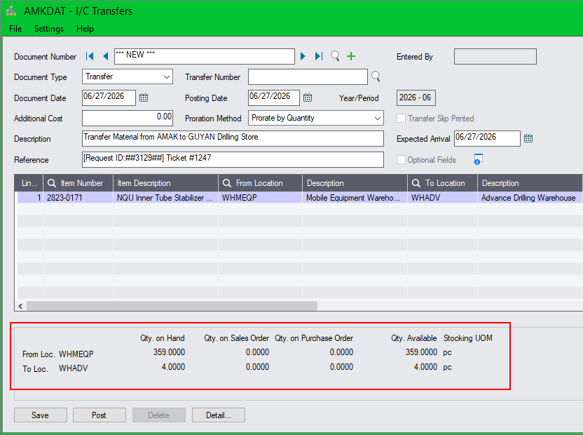
- Enter Requested Qty and Transfer Quantity
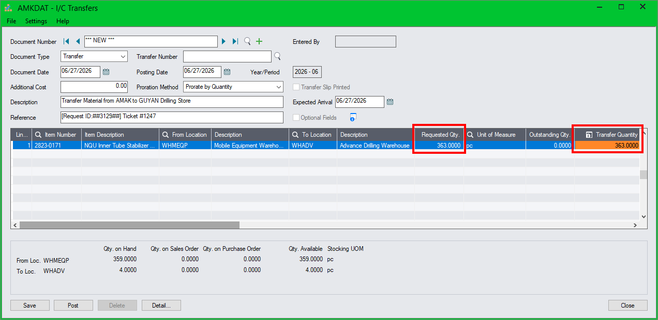
- If transfer quantity exceeds available quantity in the “From Location”, the following error will appear.
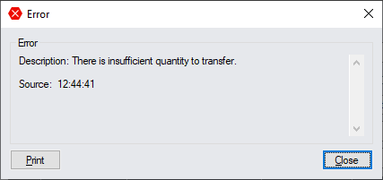
- Press Insert to add another item.
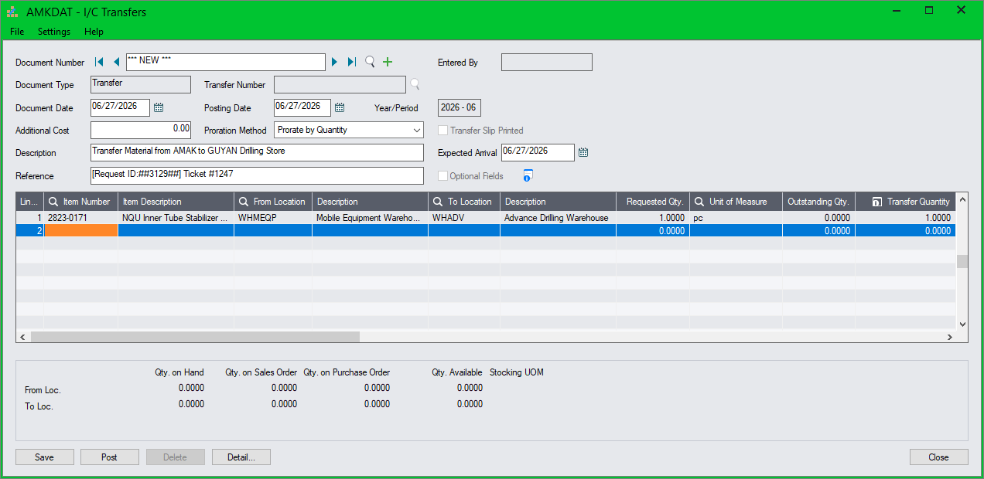
- Once all items are entered, click on Post to post immediately.
You can also click on Save to save and post later.
- The system will assign a Document Number in the format TRF-nnnnn
- The transfer will take effect once the transaction is posted.

Example of a completed transfer:
